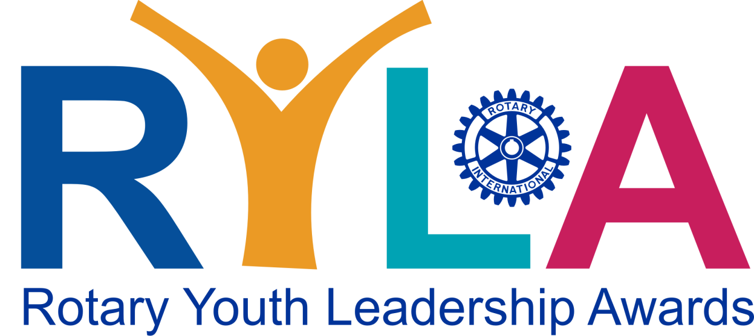
REGISTRATION FORM
May 8-9th, 2026, at Memorial University of Newfoundland, St. John’s NL

Complete online registration form or email form to jsimmons@iohs.ca no later than
Apr 24th, 2026.
Fee of $175. Payment via etransfer to: rd7815finance@gmail.com
or
cheque made out to: Rotary District 7815
Mail to: North Atlantic Rotary District 7815 PO Box 13302 St. John’s NL A1B 4B7

Section 1: Personal Information (Participant)

First Name: __________________________ Last Name: ______________________

Identifies As (optional): _____________________________________

Preferred Name (for name badge): ___________________________

Sponsoring Rotary Club (if applicable): ___________________________________

Birth Date: ____/_____/_____ School Grade: _____ Gender: __________
Day Month Year

Home Address: ___________________________________________________

E-mail Address: ________________________________________________________

Contact Phone Number: Participant: __________________

Parent/Guardian: ___________________

Section 2: Medical Information --- PLEASE BRING MEDICARE CARD WITH YOU

This information will be treated confidentially and will only be disclosed to organizers of the event as required to ensure your safety, health, and well-being.

Do you have any special dietary (i.e., food allergies) or mobility requirements?

Any other allergies or medical conditions we should be aware of?

Section 3: Emergency Contact Details

Medicare/MCP #______________________________________ Expiry Date______________

Emergency Contact Name: _______________________________Relationship: ________________

Contact #: ______________________Alternate contact: _________________________

Section 4: Written Response

Tell us a bit about yourself. Any previous leadership or volunteer experience?
What are your goals or aspirations? What do you hope to learn at RYLA?

________________________________________________________________________________________________________________________________________________________________________________________________________________________________________________________________________________________________________________________________________________________________________________________________________________________________________________________________________________________________

I agree to commit to building a positive RYLA community and to abide by the Participation Terms during the RYLA session. I give permission for Rotary to use any photographs or video taken of me, for the purpose of advertising or promotional material.

I grant permission to any adult member of the RYLA committee to authorize necessary medical treatment by any doctor or hospital. I certify that all health issues have been disclosed and that the information provided is accurate.

I understand that I will share a room with another person of the same gender as identified in this form and will have adult chaperones available throughout the night at residence.

______________________ _____________________ _________________
Applicant Signature Name Date

If Applicant is under the age of 19;

__________________________ ____________________ _________________
Parent/ legal guardian signature Name Date

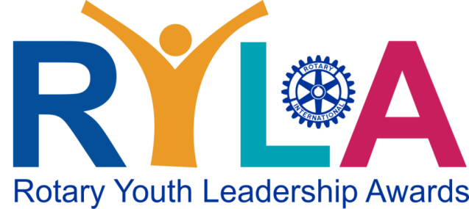
The Rotary Youth Leadership Awards (RYLA) is one of the most successful Rotary programs run by Rotary clubs around the world. District 7815 RYLA is a fun and intensive training program designed for teens (15-19 years of age) to inspire leadership and provide them with the skills to complete their goals.
What are the benefits of RYLA?
RYLA allows you the opportunity to build your problem solving and communication skills, discover strategies for becoming a dynamic leader in your school or community, explore career paths, share ideas and experiences with your peers, coordinate youth activities and/or community service projects and discuss creative approaches for resolving family, social, and professional conflicts.

Through RYLA, Rotary District 7815 aims to:
• Provide young leaders the opportunity to collaborate in a supportive environment to gain a better
understanding of their own and others’ strengths, unique qualities, and abilities
• Facilitate workshops about teamwork, communication, and motivation to develop the leadership skills
• Demonstrate Rotary's commitment to youth development and growth

When and where is RYLA held?
Rotary District 7815’s RYLA 2026 will be held at Memorial University of Newfoundland, St. John’s NL on May 8th and 9th, 2026. Registration/Check in opens at 4:00 pm on Friday. Departure/ pickup time is May 9th at 5:00 pm. Location of drop off and pick up to be provided after registration is submitted/accepted.

What is the cost for RYLA?
The total cost for the weekend is $175. This includes overnight accommodations at MUN and meals (Friday night, Saturday breakfast & lunch, snacks), as well as a certificate of completion for the John Maxwell iChoose program and certificate of participation at RYLA. It also covers the cost of our community project we will do as part of the program. Check with your local Rotary club to see if they can sponsor you.

How do I register?
Registration deadline: Apr 24th,2026
Online or email completed Registration Form to Registration Coordinator at
jsimmons@iohs.ca

How do I pay?
- Payment via e-transfer to: rd7815finance@gmail.com
- Cheque payable to: Rotary District 7815
Mail cheque to: North Atlantic Rotary District
PO Box 13302 St. John’s NL A1B 4B7

Questions? Email- jsimmons@iohs.ca

