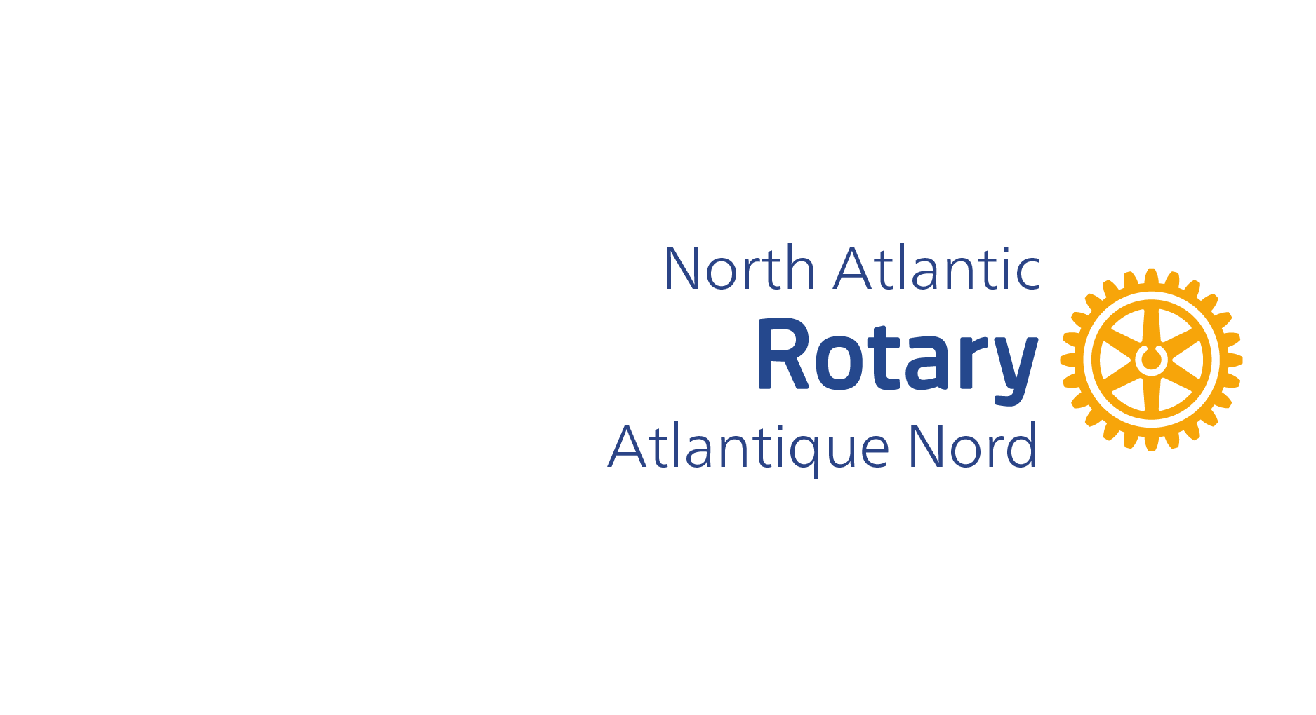
North Atlantic Rotary Atlantique Nord (District 7815) CLUB NOMINATION RESOLUTION For District Representative or Alternate on the 2026 Zone 28 Nominating Committee for Rotary International Director.
DEADLINE TO SUBMIT THIS COMPLETED FORM TO District Executive Secretary Brian Smith at smithrsx@gmail.com before 12 Midnight, Atlantic Time, Monday March 30th, 2026.

To nominate: Past District Governor_______________________________________

for North Atlantic Rotary Atlantique Nord’s (District 7815) Representative or Alternate for the 2026 Zone 28 Nominating Committee for Rotary International Director.

Proposed by: _____________________________________________ (Club Name)

WHEREAS, District Governor Marcel Gervais has called for the names of Past District Governors who could serve as the North Atlantic Rotary Atlantique Nord’s (District 7815) Representative or Alternate on the 2026 Zone 28 Nominating Committee for RI Director.
AND WHEREAS that Committee will be tasked with selecting the next RI director to represent our Zone on the Rotary International Board for the two-year July 1, 2028- June 30, 2030 term.
AND WHEREAS PDG _____________________________________________ is someone who is well informed about Rotary International, its clubs, districts zones, and the Rotary Foundation and possesses the personal qualities and skills together with the desire to represent our District on the 2026 Zone 28 Rotary International Director Nominating Committee as either the North Atlantic Rotary Atlantique Nord’s (District 7815) Council Representative or Alternate.
AND WHEREAS PDG ___________________ meets the official qualifications to be a RI District Council Representative, including:
- is a past governor at the time they are elected
- is a club member from Zone 28
- has not served twice previously as a member on the Zone 28 Nominating Committee for RI Director
- is not the RI president, president-elect, or past president, RI director, or past RI director
- agrees to attend the Zone 28 Nominating Committee meeting on a date between 15 September – 15 October 2026.
IT IS RESOLVED by the Rotary Club of _____________________________ to place
Past District Governor _________________________________ into nomination for
North Atlantic Rotary Atlantique Nord’s (District 7815) Representative or Alternate on the 2026 Zone 28 Nominating Committee for Rotary International Director.
Passed by the Rotary Club of: ______________________________________
On Date: __________, 2026

Club President
Name _______________________ & Signature: ___________________
Date: __________, 2026

Club Secretary
Name ________________________ & Signature: ___________________
Date: __________, 2026

Past District Governor Nominee
Name _________________________ & Signature: ___________________
Date: __________, 2026

